UNI BANK BOT

Digital Banking Assistence

Technology Used: Python, Streamlit FrameWork
Project Type: AI-Based Banking Assistant
Developer: Giridhar Palivela

Introduction
The UNI BANK BOT is a web-based intelligent banking assistant developed using Python and Streamlit. The main goal of this project is to simulate modern digital banking services integrated with AI-powered conversational interaction.
This chatbot helps users perform banking-related queries such as:

- Checking account balance
- Viewing account details
- Checking loan status
- EMI information
- Requesting loans
- Viewing analytics dashboard

The system also includes login authentication, multilingual support, session-based chat history storage, and a professionally designed enhanced sidebar.

Objectives of the Project
The main objectives of this project are:

- To design a smart AI-powered chatbot interface.
- To implement a secure login and logout system.
- To maintain multiple chat sessions with history.
- To provide account and loan information simulation.
- To build a dashboard with account analytics.
- To implement multilingual language support.
- To design a premium and responsive sidebar UI.

System Architecture
The system is built using a single Streamlit application structured into modular components:

Login Module

    - Handles user authentication
    - Maintains session state
    - Controls access to dashboard and chatbot

Language selector

    - Mulitiple Language Selector.
    - The entire Chat bot work on the user selected language.

  - Chatbot Module

    - Process the user inputs
    - Displays Quick responses
    - Stores the Previous chat
    - Supports Mulitiple Chat sessions
    - Deletes the unwanted chats

Account Management Module

    - Displays loan account number
    - Shows outstanding balance
    - Provides Account balance

Loan Tracking

    - Display the Running Loans
    - Creates an Application for New loans

Dashboard Module

    - User profile displays
    - Total Balance
    - Loan tracking
    - Monthly Spending
    - Monthly Saving

Enhanced Sidebar Module

    - User profile displays
    - Navigation ( Chat / Dashboard)
    - New Chat Button
    - Logout Button
    - Language Selection

Technologies Used
- Python 3.13.9
- Streamlit Framework
- Session State Management
- Basic Analytics Display

Key Features
Chatbot System
- AI-style conversational interface
- Multiple chat sessions

- Save and display chat history
- “New Chat” option
- Delete Chat History

Multilingual Support

- English
- Hindi
- Telugu
- Bengali
- Marathi
- Tamil
- Malayalam etc…

Banking Simulation

- Account balance inquiry
- Account details
- Loan account details
- EMI tracking
- Loan request simulation

Dashboard Analytics

- Account Balance Display
- Loan Outstanding Display
- Monthly Spendings
- Monthly Savings
- Recent trasactions

Enhanced UI

- Professional sidebar
- Clean layout
- Organized navigation
- Responsive design

Problems Faced During Development
During the development of the UNI BANK BOT, several challenges were encountered:

Database Schema Mismatch

The most significant hurdle was an outdated local database schema that only had username and password columns.

Login State Persistence

Maintaining login status after page refresh required proper session handling.

UI Visibility & Contrast

When applying the custom blue gradient, global CSS rules initially made all text dark, rendering it invisible against the dark blue sections

Logic Regression Risk

During the implementation of the chat deletion feature, a code-replace error temporarily removed the load_chat function.

Future Enhancements
The project can be improved further with:

- Integration with real AI models (OpenAI API/ Gemini API ).
- Database integration (MySQL / MongoDB).
- OTP-based authentication.
- Voice-enabled chatbot.
- Role-based access control (Admin/User)

UI Outputs

LOGIN PAGE:

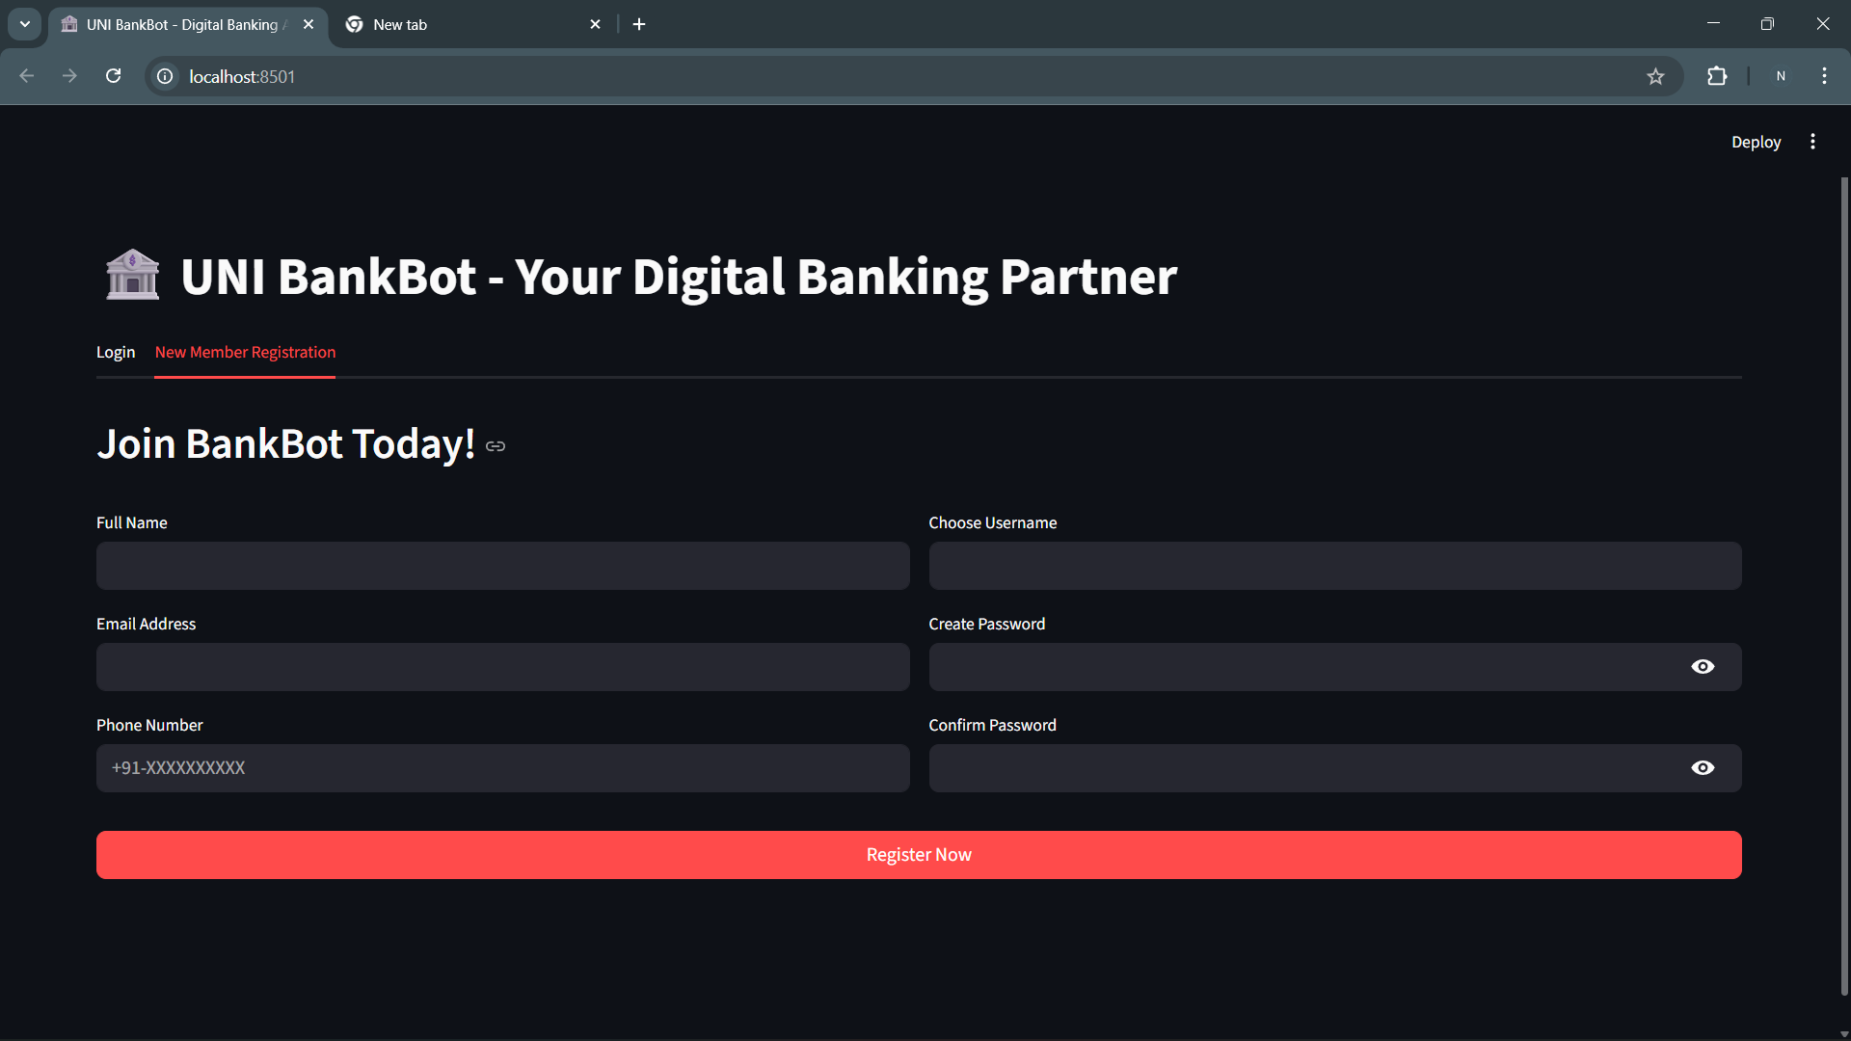

LANGUAGE SELECTOR PAGE:

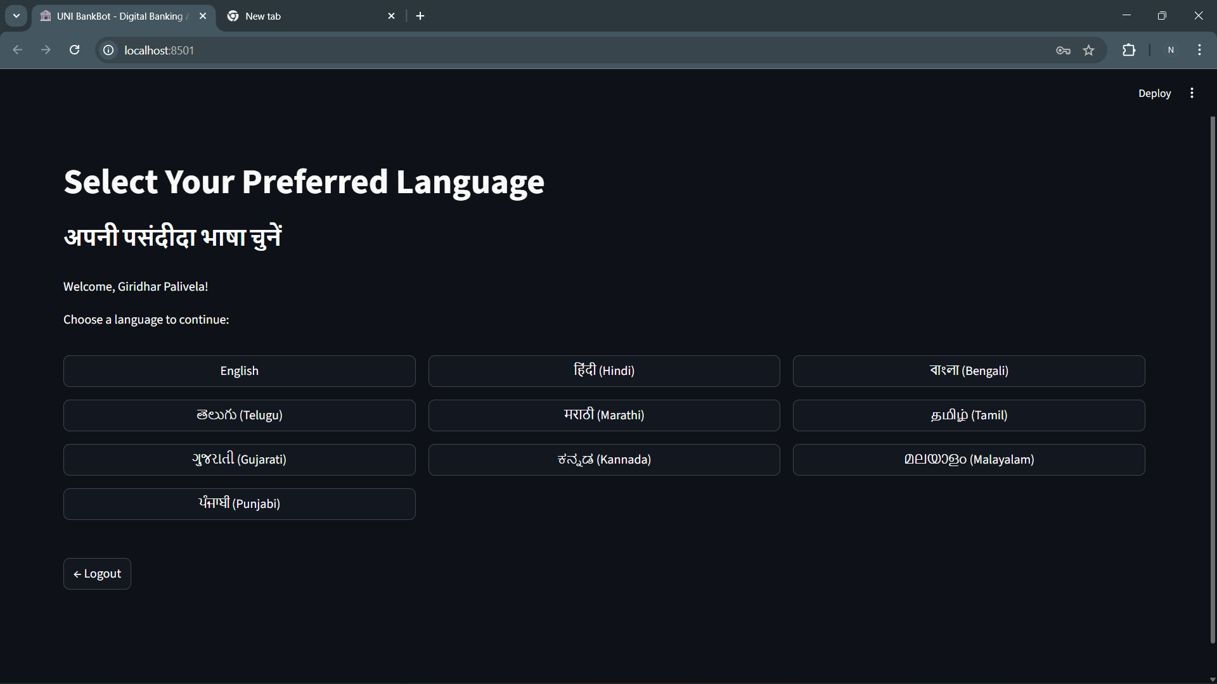

USER DASHBOARD:

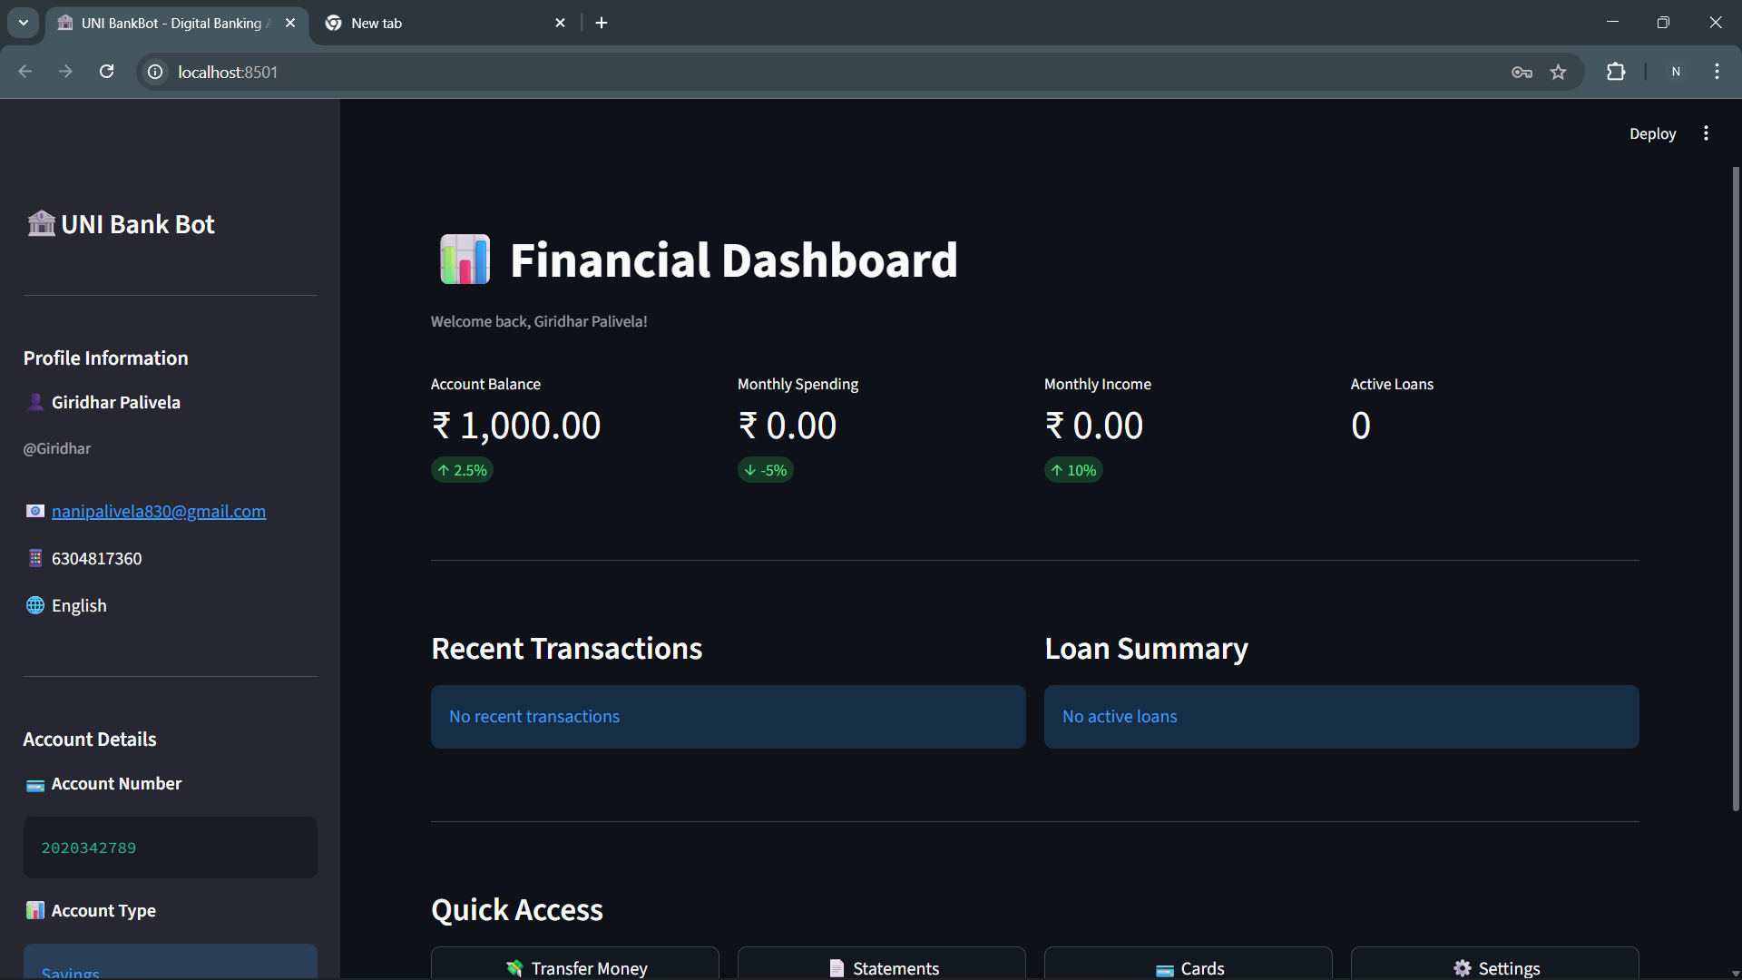

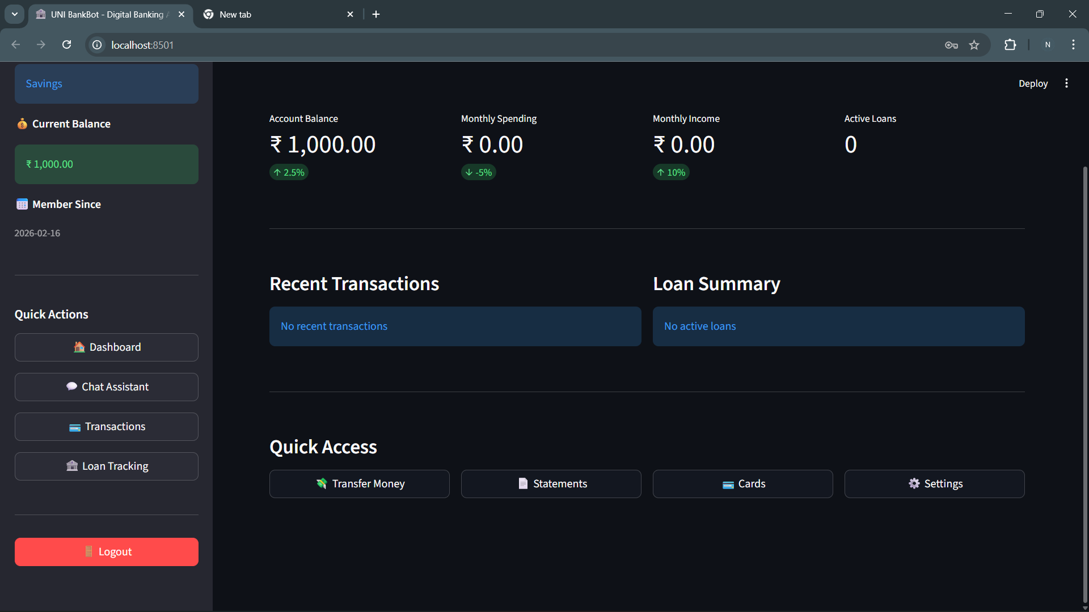
CHATBOT UI:

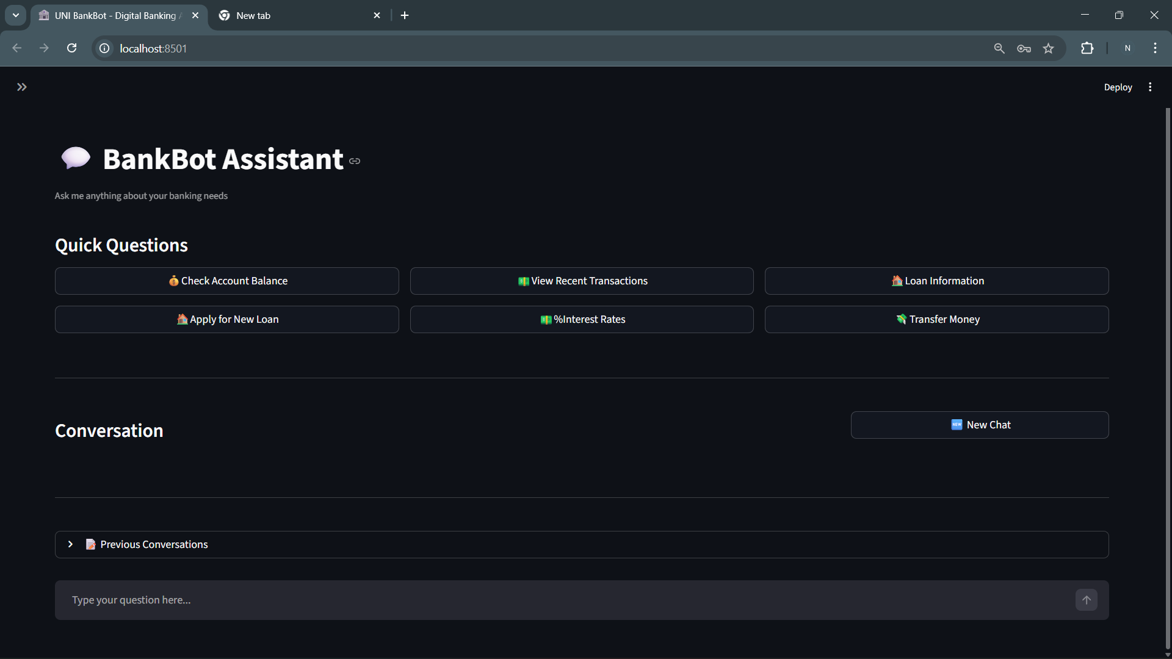

TRASACTION HISTORY:

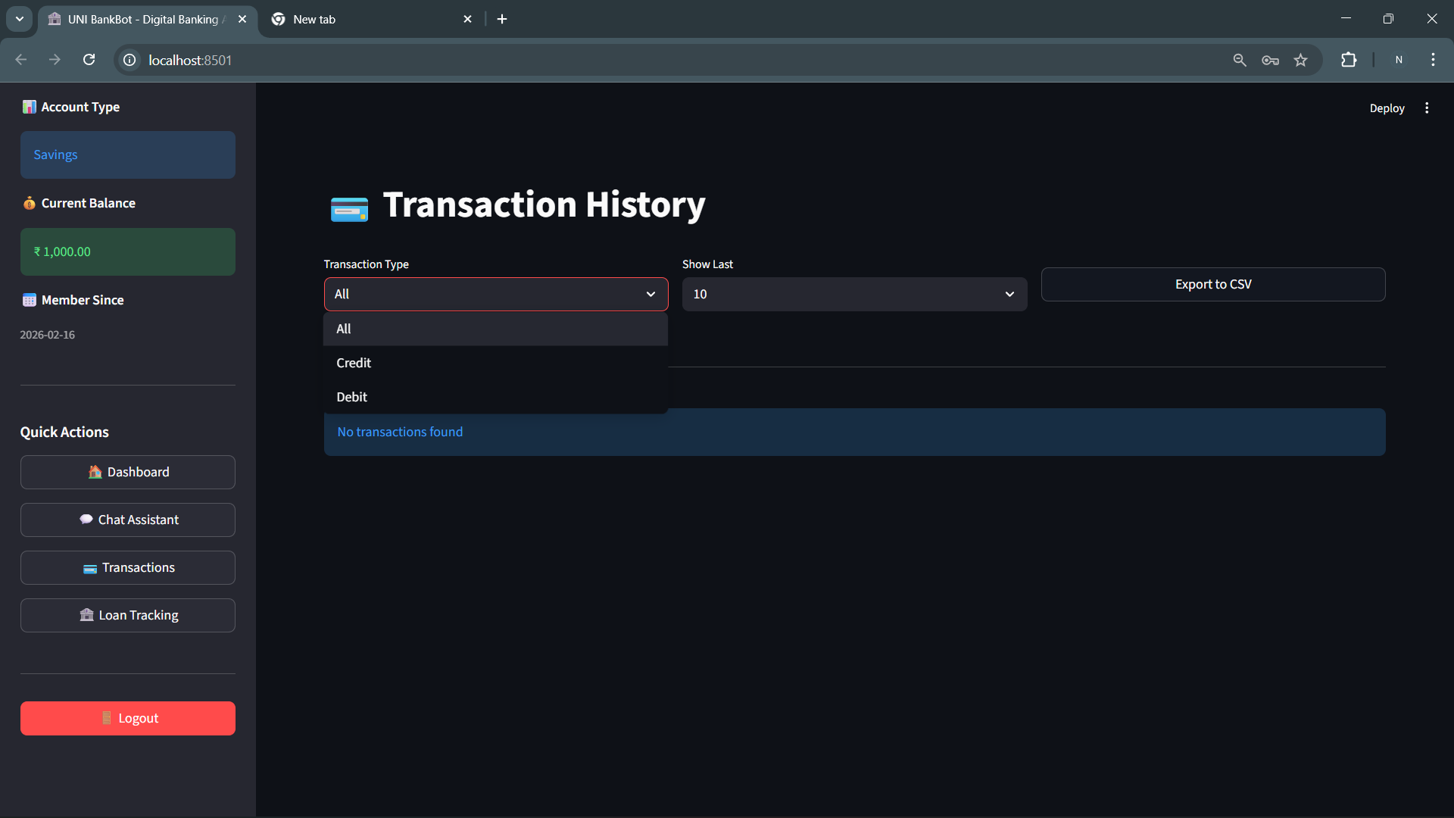

- Conclusion
The UNI BANK BOT successfully demonstrates how AI-powered systems can enhance digital banking services. The integration of authentication, multilingual chatbot, dashboard analytics, and enhanced UI provides a complete simulation of modern banking applications.
This project serves as a strong foundation for developing real-world AI banking assistants and intelligent financial platform.

